Abstract— The aim of this project is to predict the taxi fare :By getting the data – date and time (i.e either future or present) it predicts the taxi fare which includes factors like peak hours, week days, distance etc.The distance can be calculated using mathematical formulae.(Haversine formula).The algorithm used here is k-Nearest Neighbor (KNN) Furthermore, to achieve our goal, we proposed our subsequent analysis i.e. Analysis on Region. Here we accumulate information which was allied with location like Pickup Latitude, Pickup Longitude, Drop-off Latitude and Drop-off Longitude.
PREDICTION OF TAXI FARE USING EXPLORATORY ANALYSIS

( June 21, 2019)
P.Princy ,S. Kirthana Gomathy , K.Aishwariya

INTRODUCTION

Transportation has been proved as the most vital service in large cities. Diverse modes of transportation are accessible. In
large cities in the United States and cities around the world, taxi mode of conveyance plays a foremost role and used as the best substitute for the general public use of transportation to get their
necessities.
The goal of this project is to predict the fare of a taxi trip , by using the information's like pickup and drop off locations, the pickup date and time travelling .This system can also predict the taxi fare for future days by getting date as an input. Here we have used various analysis on passenger count, latitude and longitude and fareamount. So that the user can know their range and can book the taxi easily according to their preferences. Based on the analysis, the user can predict the taxi fare for future dates and can decide to book the taxi or not.

DATA
The data used in this study are trained data sets which has pickup latitude , pickup longitude ,dropoff latitude ,dropff longitude and passenger count. The data was processed to extract separate time features like year, month, day, weekday, hour and minute from the date and time of each ride. Predictive estimates of future transit time shows the importance of being able to predict time travel without having real time data of traffic.
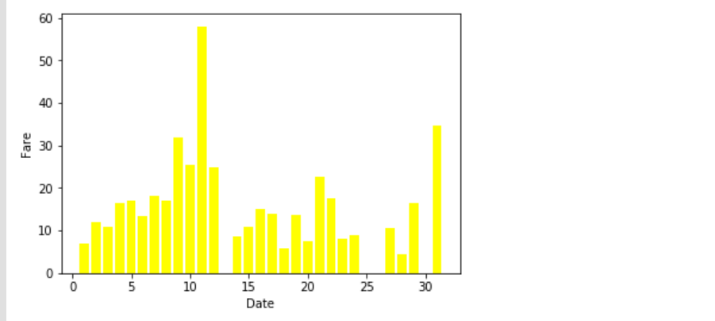
A. Date and Fare

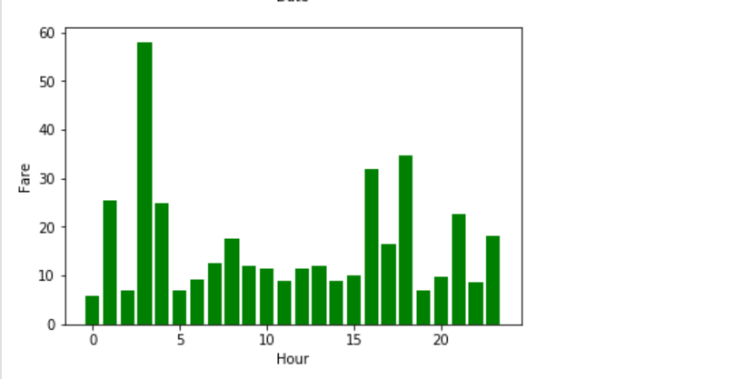
B.Hour and Fare
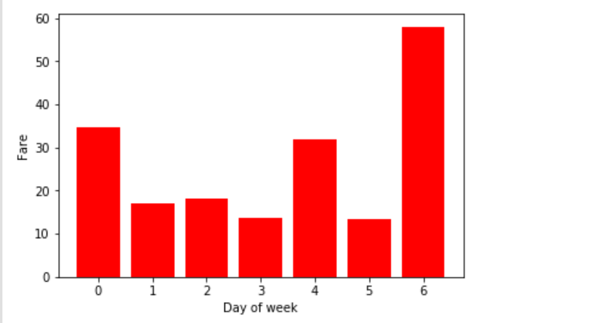
C.Days and Fare

II.Models and Method
We have used haversine formula to find the distance. The formula used is:

1.a = sin²(Δφ/2) + cos φ1 ⋅ cos φ2 sin²(Δλ/2)
2.c = 2 ⋅ atan2( √a, √(1−a) )
3.d = R ⋅ c
(where R= radius of the earth=6371km)

Existing model-The existing model uses random forest regression. A random forest model does not scale very well for time-series data and might need to be constantly updated or trained with some random data that lies outside the range of training set.

Proposed model-In the proposed model KNN algorithm was used. The KNN alogorithm is used
because
1.Easy to calculate time
2.Easy to predict the output.
Here we have used time to predict the fare amount in addition to distance. The reason for including time component is because only with distance and current date and time the user can predict only the fare of the taxi on that particular date and time. This may be a uncomfortable for the user who wants to book the taxi before the day. But our proposed system overcome this by including the time features.
We have also created GUI for our proposed system.
III.RMSE AND MSE:

Mean Square Error:47489.8674634

Root Mean square Error: 217.921700304

IV.PREDICTION:

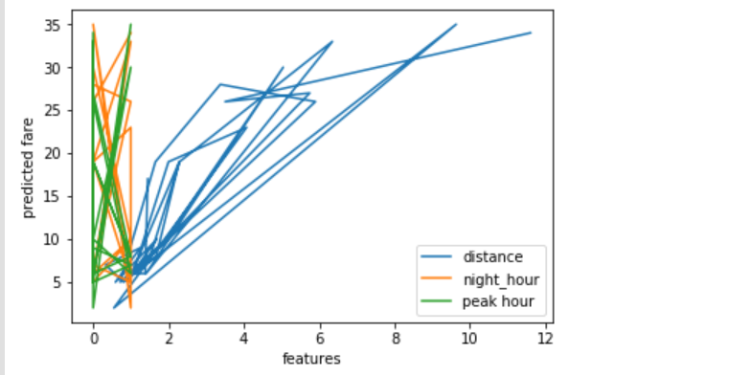

V.Conclusion:
In this system we can predict the fare amount in future. Considering what is and what is not accounted for in the model is their predicting results are fairly accurate. And in future to improve the prediction accuracy, more variabilities need to be considered and modeled. It can be said that in more affluent parts of the city and during peak hours, a higher percentage tip will be paid to any taxi driver. Hopefully with this information, taxi drivers can better plan their routines for the day in order to increase their own earnings.

References:
[1] Fare and Duration Prediction: A Study of New York City Taxi Rides Christophoros Antoniades, Delara Fadavi, Antoine Foba Amon Jr. December 16, 2016

[2] Competition : New York City Taxi Fare Prediction by Kuldeep Patel.
(https://www.kaggle.com/c/new-york-city-taxi-fare-prediction)

[3] How Taxis Arrive at Fares? -Predicting New York City Yellow Cab Fares by Susan Li.

[4]Vanajakshi, L., S. C. Subramanian, and R. Sivanandan. "Travel time prediction under heterogeneous traffic conditions using global positioning system data from buses." IET intelligent transport systems 3.1 (2009): 1-9.

[5] NYC Taxi Trip and Fare Data Analytics using Big Data Umang Patel Department of Computer Science and Engineering University of Bridgeport, USA.

.

 

